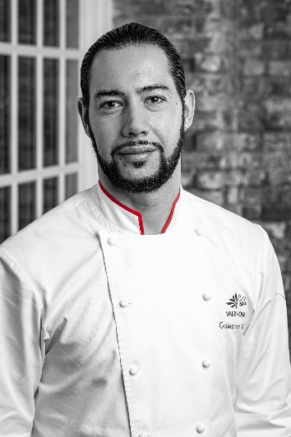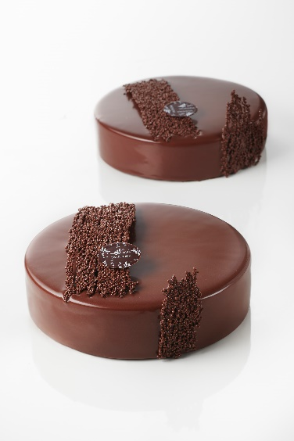**May 1-3 2023**

Pastry by

Guillaume Roesz

Join us for this exciting 3-day class organized by Valrhona.

**PROGRAM:** Take this class to enhance your pastry case offering! Come learn hands-on from l’École Valrhona Executive Pastry Chef Guillaume Roesz how to make traditional and modern French travel cakes, tarts, cakes, and petits gateaux.

**OBJECTIVES:**

* Explore different and unusual flavors, fillings, and ingredients in pastry
* Learn how to preserve your pastries
* Practice tempering different kinds of Valrhona chocolate
* Give a new look to your pastry case and offer a new product range to your customers
* Understand gluten-free and dairy-free ingredients, and how to use them in your creations

**We recommend contacting Valrhona to confirm enrollment before booking a trip to Los Angeles.**

**DATE AND TIME:**

Mon, May 1, 2023 9:00 AM – Weds, May 3, 2023, 5:00 PM PST

**LOCATION:**

Bakon USA 20906 Higgins Court Torrance, CA 90501

Register at: <https://www.valrhona.us/our-classes/valrhona-classes/classes-calendar/registration?id=2916>